WSJ Online, 8/11/2019

The Turn in the Yield Curve

What the upside-down gap between shorter- and longer-term bond yields is indicating about the markets and the economy
By Daniel Kruger and Peter Santilli
Aug. 11, 2019 8:00 am ET
A key market barometer of the risk of future recessions is sounding its loudest warning since April 2007, months before the start of the last financial crisis.
Shorter-term bond yields have climbed above longer-term ones, a phenomenon known as an inverted yield curve. That tends to happen ahead of recessions. Yet economic growth remains steady and the labor market strong, stoking debate among investors about what the signal means now.
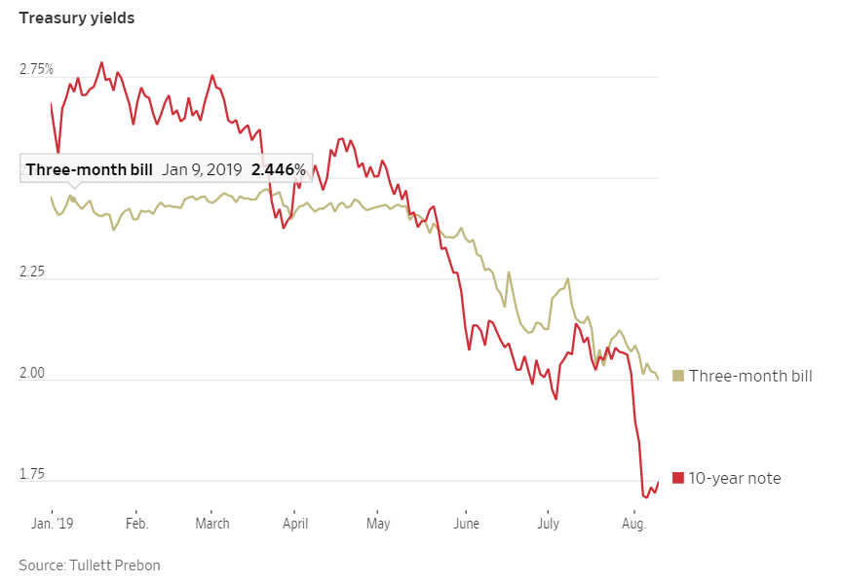
An inverted curve indicates that investors expect lower interest rates—and thus growth and inflation—down the road than they anticipate in the near future. As their expectations for these key economic measures fall, the predictability of bonds’ steady principal and interest payments becomes more attractive. That drives down yields, which fall when bond prices rise. Investors also begin to wager that the Fed will reduce interest rates, which pulls yields lower.
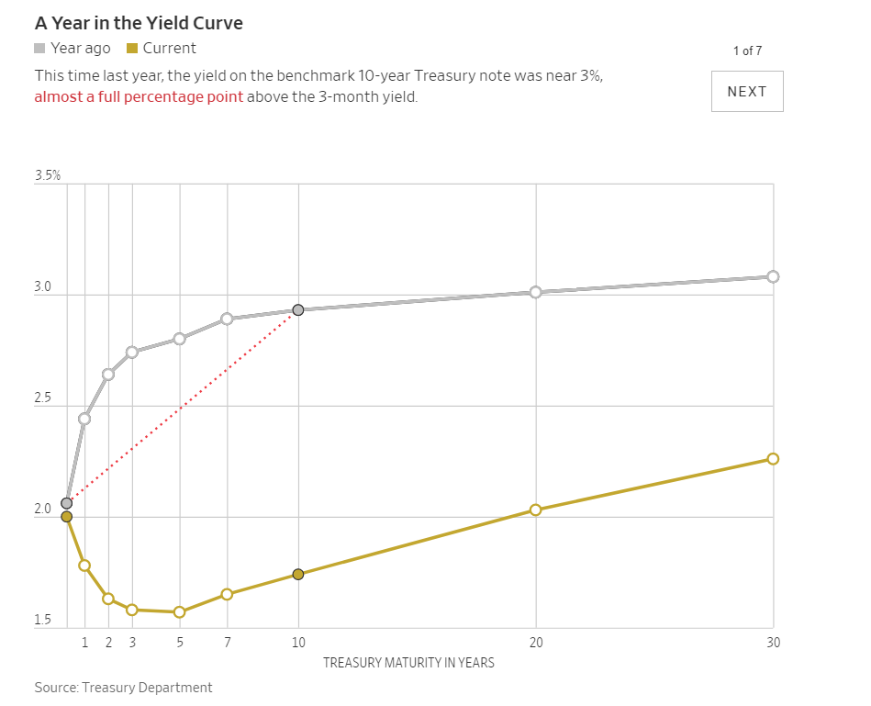
The yield curve has typically inverted before recessions. Investors disagree about whether short-term yields exceeding those in the longer-term has a mechanical effect on the economy—by reducing the willingness of banks to lend, for example—or whether yields merely reflect changes in sentiment. The curve’s return to a positive slope also tends to follow a pattern: As the Fed cuts interest rates, reducing the cost of short-term borrowing, longer-dated yields tend to rise. This helps revive expectations for growth and inflation.
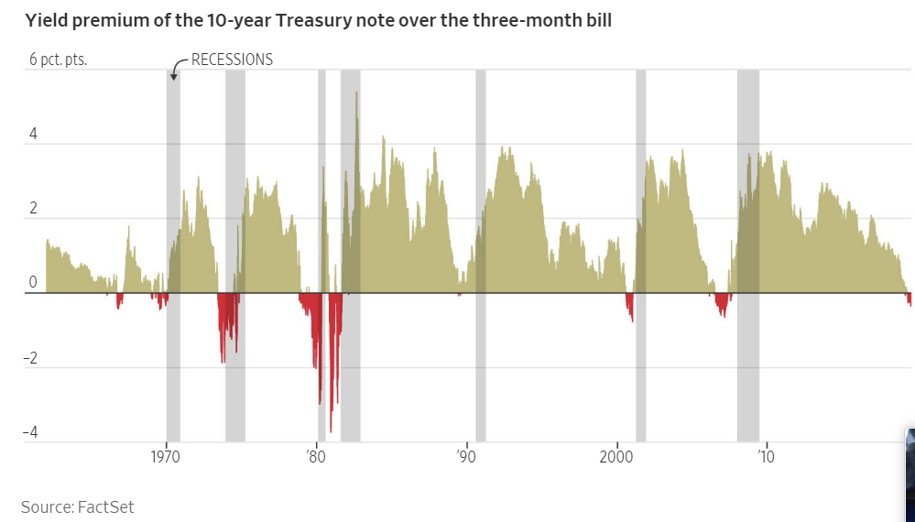

Stocks often continue to gain after the yield curve inverts. This is because short-term yields often rise above longer-term yields well before the economy shows signs of slowing down. This can leave investors uncertain about whether the yield curve’s traditional role in signifying future recessions applies to current circumstances. That has been the case this year, as stocks have risen and the economy expanded at a 2.1% annualized pace in the second quarter after the curve inverted in March.
